SDLC FOR MY SMART DAILY PLANNER

My Smart Daily Planner

Introduction
My Smart Daily Planner is a simple web project created to help users plan their daily activities easily. The system allows users to add tasks, set priorities, mark tasks as completed, delete tasks, and rearrange tasks. The aim is to make daily planning simple and organized.

1. Planning
The idea for this project came from the need to manage daily tasks properly. Many people forget tasks or feel overwhelmed, so this planner was designed to help users keep track of what they need to do in a clear and simple way.

2. Analysis
Functional Requirements
• Add a new task
• Set task priority (High, Medium, Low)
• Mark a task as done or undo
• Delete tasks
• Reorder tasks
• Save tasks so they remain after refreshing the page

Non-Functional Requirements
• Easy to use
• Simple and clean interface
• Fast response
• Works on a web browser

3. Design

The system is designed as a single web page consisting of:
• A header showing the project title
• An input area to add tasks and select priority
• A task list displaying all tasks
• Buttons for marking tasks done, undoing, and deleting tasks

The design ensures that the names and features used match what is implemented in the code.

4. Implementation
The project was implemented using:
• HTML for structuring the page
• CSS for styling and layout
• JavaScript for adding tasks, marking tasks done, deleting tasks, reordering tasks, and saving tasks.
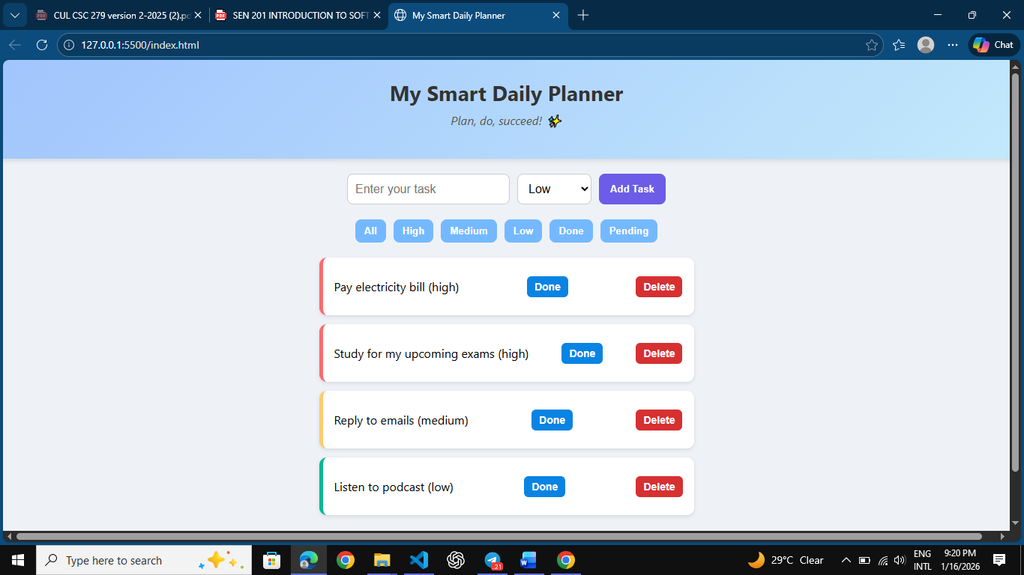
‘’Shows the planner layout with task and header’’

5. Testing

The system was tested by:
• Adding tasks
• Changing task priorities
• Marking tasks as done
• Deleting tasks
• Refreshing the page to confirm tasks are saved.

All features worked as expected.

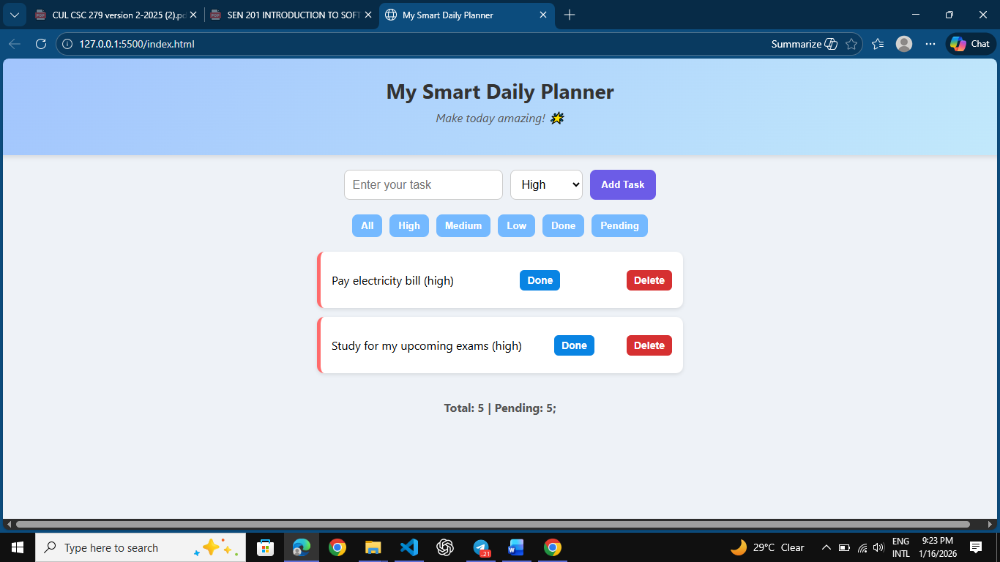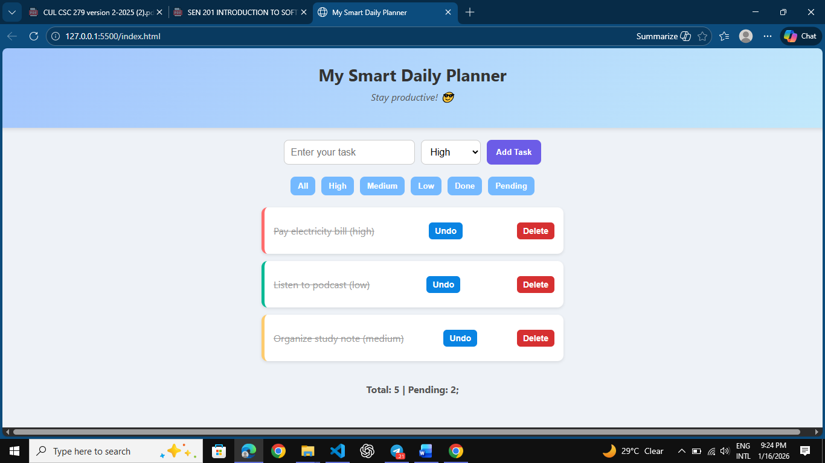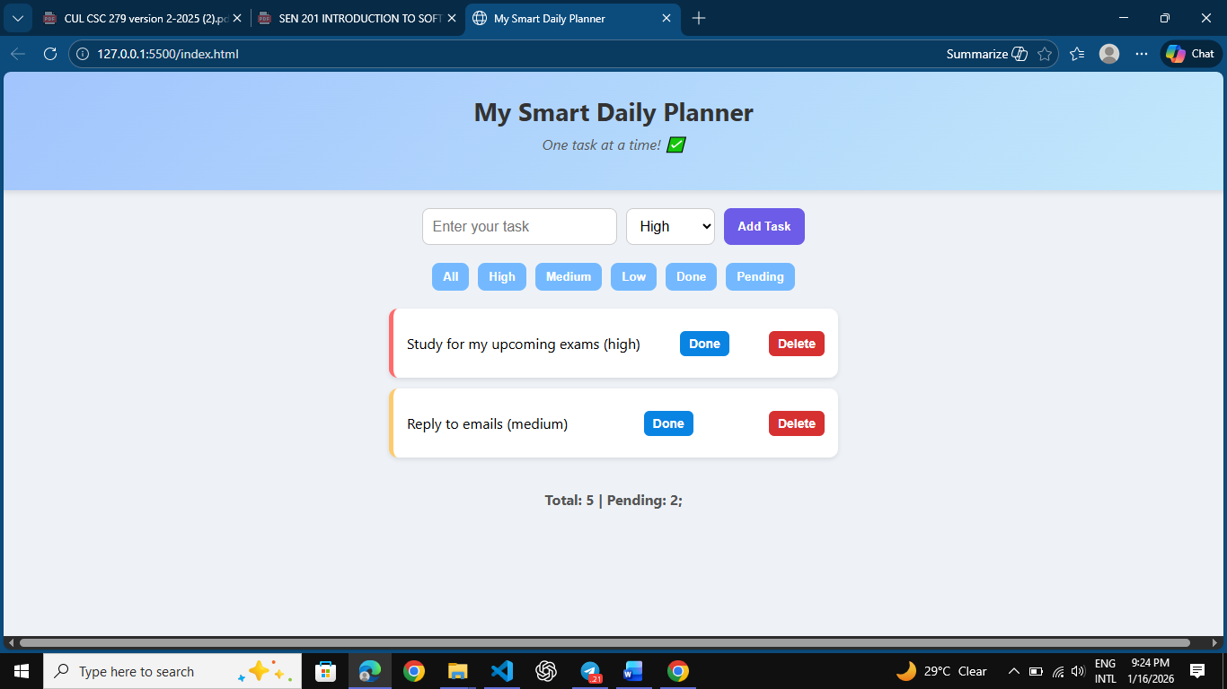
‘’Some screenshot of how the planner works showing high, medium, low task and also shows a task marked done and the delete button’’

6. Deployment
The completed project was uploaded to GitHub. The repository contains all the project files and can be accessed using the provided GitHub link.

GitHub Link: (Insert your link here)

